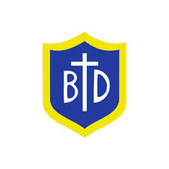
EYFS RE Newsletter
Spring 2026
Desert to Garden
During this topic, the children will learn that Lent is a time to care for others. They will be making their own special Lenten promises. Pupils will also learn that Jesus died on a cross and it is a sad time. Towards the end of the topic, pupils will learn that Jesus was given new life by God his Father. Jesus rose and everyone celebrates this at Easter. They will be learning to retell some parts of the Holy Week story and reflecting on the feelings of Jesus and his friends- the Disciples.


This term your child will be studying two different topics in Religious Education:
- Galilee to Jerusalem
- Desert to Garden
Each topic will last approximately six weeks.

Galilee to Jerusalem
In this topic, the pupils will learn that The Three Wise Men visited Jesus with gifts after he was born and they will think about their own special gifts and talents that God has given them. They will also begin to understand that Jesus is God’s Son and came for everyone. Pupils will learn to show that Jesus loves and welcomes everyone, through the story of Jesus welcomes the little children.
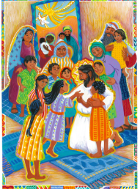

Catholic Social Teaching
Our Catholic Social Teaching focuses will be:
Spring 1: Solidarity and Peace
Spring 2: Community and Participation.

Special Dates this term
6th January- The Epiphany of the Lord.
11th January: The Baptism of the Lord.
2nd February: The Presentation of the Lord.
18th February: Ash Wednesday
25th March- The Annunciation of the Lord.
29th March- Palm Sunday
3rd April- Good Friday
5th April- Easter Sunday

Love- Learn- Believe

