
Year 1 RE Newsletter
Spring 2026
Desert to Garden
The focus of this branch is to learn a little about the season of Lent as a time to prepare for Easter and to know the story of the last week of Jesus’ life, his death, and resurrection. Pupils will experience Lent traditions as part of the school’s prayer life and through the charitable activities in Lent.
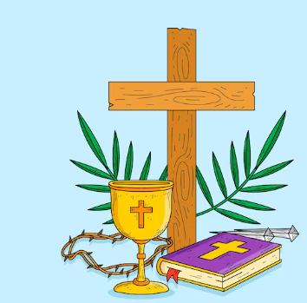
This term your child will be studying two different topics in Religious Education:
- Galilee to Jerusalem
- Desert to Garden
Each topic will last approximately six weeks.

Galilee to Jerusalem
This unit helps children learn about the life of Jesus. The children will explore key stories from Jesus’ journey from Galilee to Jerusalem, discovering how He taught people to love, forgive and care for others. Through stories, discussion and simple activities, the children will learn about stories such as the Presentation of Jesus in the Temple and Jesus blesses the children.
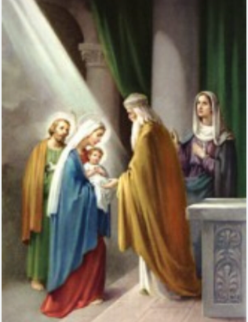

Special Dates this term
6th January- The Epiphany of the Lord.
11th January: The Baptism of the Lord.
2nd February: The Presentation of the Lord.
18th February: Ash Wednesday
25th March- The Annunciation of the Lord.
29th March- Palm Sunday
3rd April- Good Friday
5th April- Easter Sunday

Love- Learn- Believe
Catholic Social Teaching
Our Catholic Social Teaching focuses will be:
Spring 1: Solidarity and Peace
Spring 2: Community and Participation.

