
Year 2 RE Newsletter
Spring 2026
Desert to Garden
In this branch, pupils in Year Two will revisit scripture from the previous year to deepen their learning about Holy Week. They will make links between the forgiveness Jesus shows at his Crucifixion and the ministry of Jesus studied in the previous branch. They will also explore how Lent is a time of reconciliation and forgiveness for Christians. Pupils will also develop an early understanding of the Sacrament of Reconciliation. 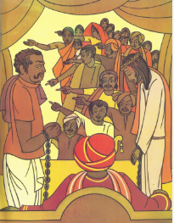
This term your child will be studying two different topics in Religious Education:
- Galilee to Jerusalem
- Desert to Garden
Each topic will last approximately six weeks.

Galilee to Jerusalem
In this branch, pupils will deepen their knowledge from Year One about who Jesus is and understand how he teaches about the nature of God through parables and miracles. Jesus used parables to help people to understand more about God and the children will be discussing the meanings of parables such as The Lost Sheep.



Catholic Social Teaching
Our Catholic Social Teaching focuses will be:
Spring 1: Solidarity and Peace
Spring 2: Community and Participation.

Special Dates this term
6th January- The Epiphany of the Lord.
11th January: The Baptism of the Lord.
2nd February: The Presentation of the Lord.
18th February: Ash Wednesday
25th March- The Annunciation of the Lord.
29th March- Palm Sunday
3rd April- Good Friday
5th April- Easter Sunday

Love- Learn- Believe

