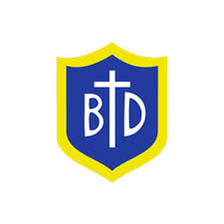
Year 3 RE Newsletter
Spring 2026
Desert to Garden
In this topic, pupils will learn more about the Mass, with a special focus on the Eucharist. They will explore the story of Jesus feeding a large crowd, and how this shows his love and care for people. The children will learn how this miracle helps us understand what happened later at the Last Supper, when Jesus shared bread and wine with his friends. The children will also learn about the Liturgy of the Eucharist. They will come to understand that the Mass is a special celebration where Catholics give thanks to God and remember Jesus’ life, death and Resurrection. Throughout the topic, children will also continue to take part in prayer and worship in school and parish life, especially during Lent, Holy Week and Easter.
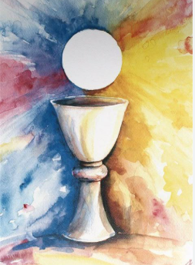

This term your child will be studying two different topics in Religious Education:
- Galilee to Jerusalem
- Desert to Garden
Each topic will last approximately six weeks.

Galilee to Jerusalem
In this branch, pupils will learn about the Gospel of Saint Matthew. They will learn about the nature of God through the miracles and parables of Jesus as told in Matthews Gospel. Pupils will also be learning in greater depth about the Sacrament of Reconciliation to help prepare them for their First Holy Communion.

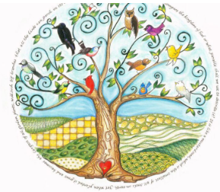

Special Dates this term
6th January- The Epiphany of the Lord.
11th January: The Baptism of the Lord.
2nd February: The Presentation of the Lord.
18th February: Ash Wednesday
25th March- The Annunciation of the Lord.
29th March- Palm Sunday
3rd April- Good Friday
5th April- Easter Sunday

Catholic Social Teaching
Our Catholic Social Teaching focuses will be:
Spring 1: Solidarity and Peace
Spring 2: Community and Participation.

Love- Learn- Believe

