
Year 5 RE Newsletter
Spring 2026
Desert to Garden
In this branch, Pupils will learn about the Ash Wednesday Mass, and explore the significance of the words spoken by the Priest. Pupils will also be learning about the Temptation of Jesus in the desert and they will reflect on the idea of conscience and making moral choices. Pupils will explore the idea that during Lent people choose to strengthen their relationship with God, make just choices and show solidarity with those who have less.
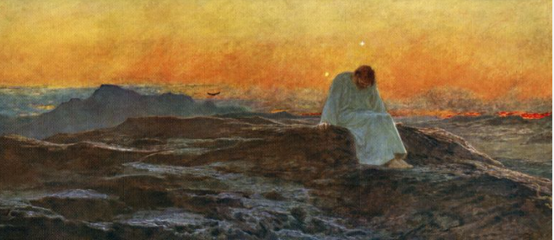

This term your child will be studying two different topics in Religious Education:
- Galilee to Jerusalem
- Desert to Garden
Each topic will last approximately six weeks.

Galilee to Jerusalem
In this topic, Year 5 children will learn about the new law Jesus taught, which is based on loving God and loving other people. They will explore how Jesus brought new meaning to the Law of Moses and showed people how to live with kindness, fairness and compassion. The children will also learn about the Transfiguration, a special event when Jesus’ friends Peter, James and John saw him revealed in God’s glory alongside Moses and Elijah. Through stories, parables and prayer, pupils will discover how Jesus taught love of our neighbour through his actions and words, and how the Our Father brings together the key message of the Gospel.
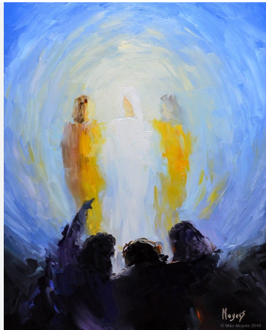

Catholic Social Teaching
Our Catholic Social Teaching focuses will be:
Spring 1: Solidarity and Peace
Spring 2: Community and Participation.

Special Dates this term
6th January- The Epiphany of the Lord.
11th January: The Baptism of the Lord.
2nd February: The Presentation of the Lord.
18th February: Ash Wednesday
25th March- The Annunciation of the Lord.
29th March- Palm Sunday
3rd April- Good Friday
5th April- Easter Sunday

Love- Learn- Believe

