
Year 6 RE Newsletter
Spring 2026
Desert to Garden
During Lent, the children will learn about the final part of Jesus’ journey from Galilee to Jerusalem. They will hear stories from St John’s Gospel that help them understand what happened to Jesus at the end of His life and why these events are important to Christians. Through storytelling, discussion and reflection, the children will explore themes of love, sacrifice, light and hope, and begin to understand why Jesus is special to Christians.
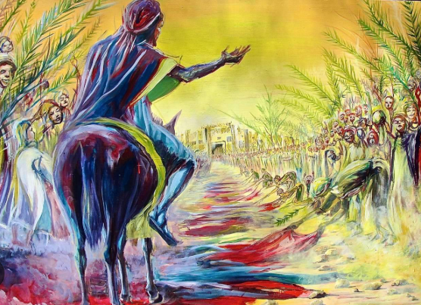

This term your child will be studying two different topics in Religious Education:
- Galilee to Jerusalem
- Desert to Garden
Each topic will last approximately six weeks.

Galilee to Jerusalem
In this topic, the pupils will be studying the Gospel of John. They will learn that John shows Jesus as the messiah through seven special signs in his Gospel. Pupils will also be exploring the seven Sacraments in greater detail. They will understand how the Sacraments help to draw us closer to God. Pupils will also link elements of the Sacraments to Saint Johns Gospel.
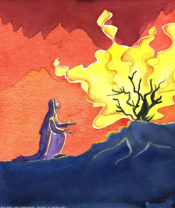

Catholic Social Teaching
Our Catholic Social Teaching focuses will be:
Spring 1: Solidarity and Peace
Spring 2: Community and Participation.

Special Dates this term
6th January- The Epiphany of the Lord.
11th January: The Baptism of the Lord.
2nd February: The Presentation of the Lord.
18th February: Ash Wednesday
25th March- The Annunciation of the Lord.
29th March- Palm Sunday
3rd April- Good Friday
5th April- Easter Sunday

Love- Learn- Believe

