
Year 4 RE Newsletter
Spring 2026
Desert to Garden
In this branch, pupils will explore the Lenten themes of forgiveness and reconciliation and the idea that devotion to God leads a person to do good works. They will also look at Holy Week in St Matthew’s gospel and see that St Matthew shows Jesus as the servant-Messiah. For Lent, they will explore two parables, The Prodigal Son and The Parable of the Judgement of Nations, reflecting on the meanings these parables hold for believers.
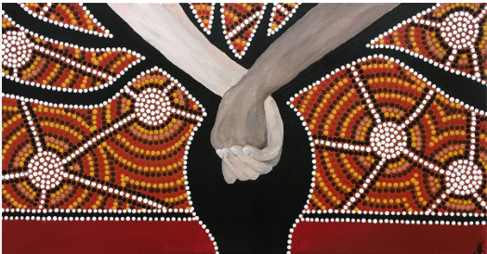

This term your child will be studying two different topics in Religious Education:
- Galilee to Jerusalem
- Desert to Garden
Each topic will last approximately six weeks.

Galilee to Jerusalem
In this topic, the children will learn more about who Jesus is and why he is important. They will explore Jesus’ question to his friend Peter, “Who do you say I am?”, and think about what it means to believe in Jesus today. The children will learn about Jesus as a servant leader who cared deeply for others, especially people who were poor, sick, or left out. Pupils will also learn about the world Jesus lived in and how people at that time understood illness. They will discover that some people who were ill were often excluded from society, and how Jesus’ healings showed God’s love by welcoming everyone. Through stories from the Bible, children will reflect on kindness, inclusion, and caring for others.
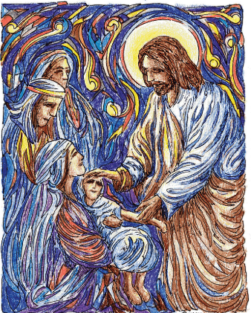

Catholic Social Teaching
Our Catholic Social Teaching focuses will be:
Spring 1: Solidarity and Peace
Spring 2: Community and Participation.

Special Dates this term
6th January- The Epiphany of the Lord.
11th January: The Baptism of the Lord.
2nd February: The Presentation of the Lord.
18th February: Ash Wednesday
25th March- The Annunciation of the Lord.
29th March- Palm Sunday
3rd April- Good Friday
5th April- Easter Sunday

Love- Learn- Believe

